Create a simple cloud software application for Flight Reservation System using any Cloud Service Provider to demonstrate SaaS include the necessary fields such as one way, round trip, From, to, Departure, Departure, Travelers & Class, Fare Type, International and Domestic Flights etc.

Step1: Signing in Zoho Website to create an app for Flight Reservation System.

Entering Login Details of Client: Travel through Air.

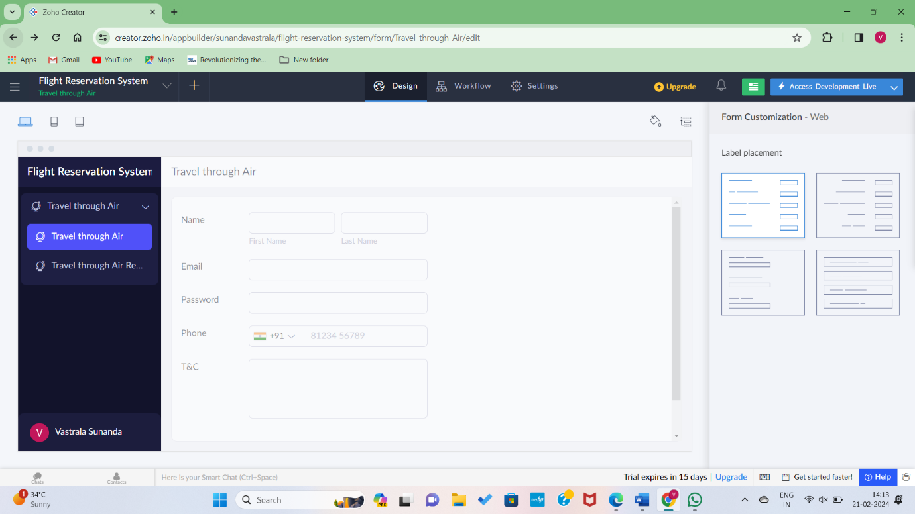

Step 2: Enter the needed files for the app login.

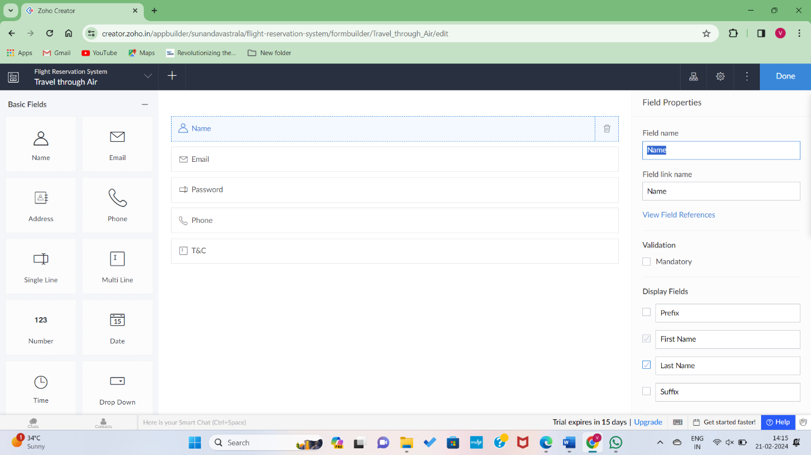

Step 3: Go to Done and Build the form for further step.

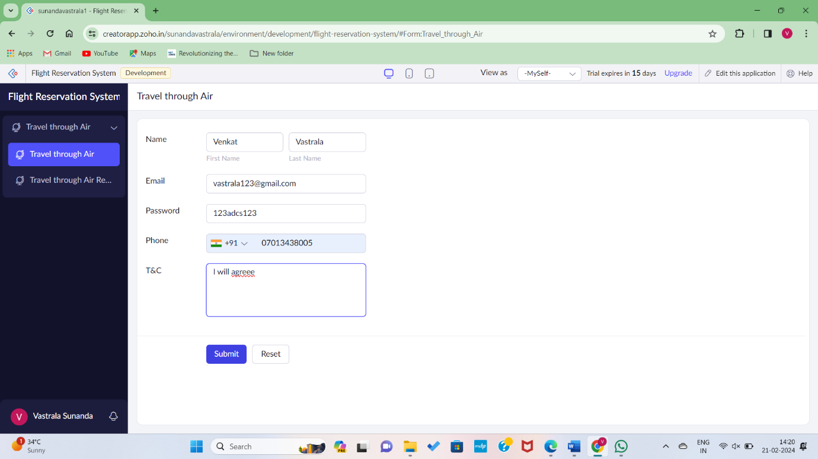

Step 4: Go to the Access Development live and enter the Details of the client and click submit button.



Step 5: Open The Travel through air Report on left hand side of the desktop.

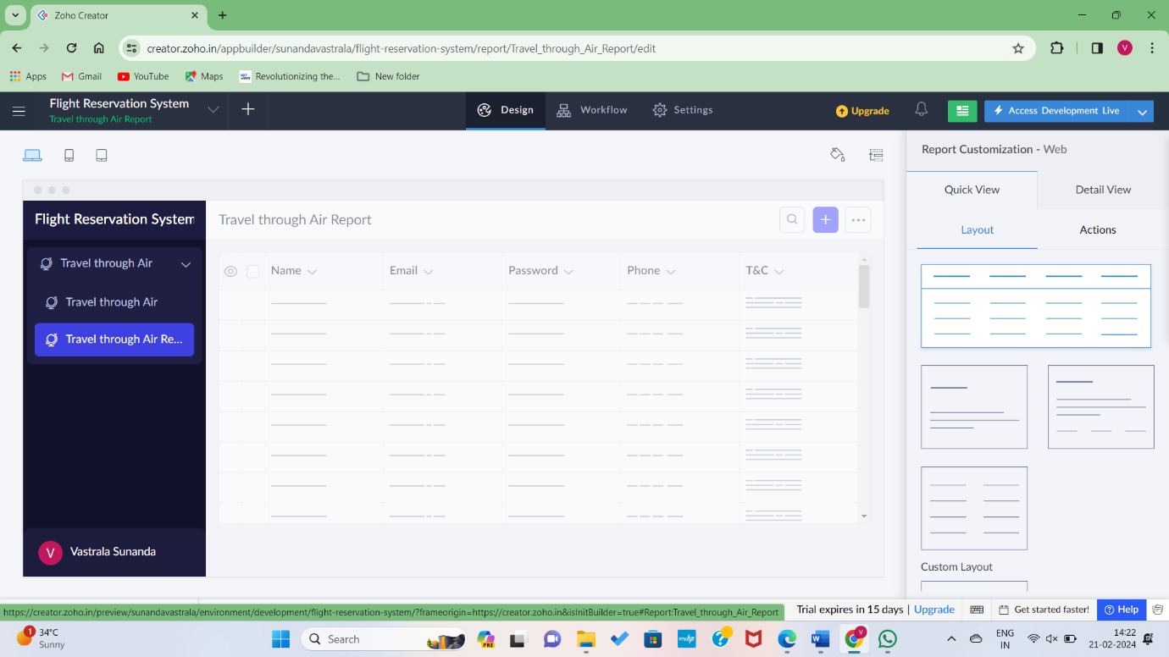

Step6: We can get the details.

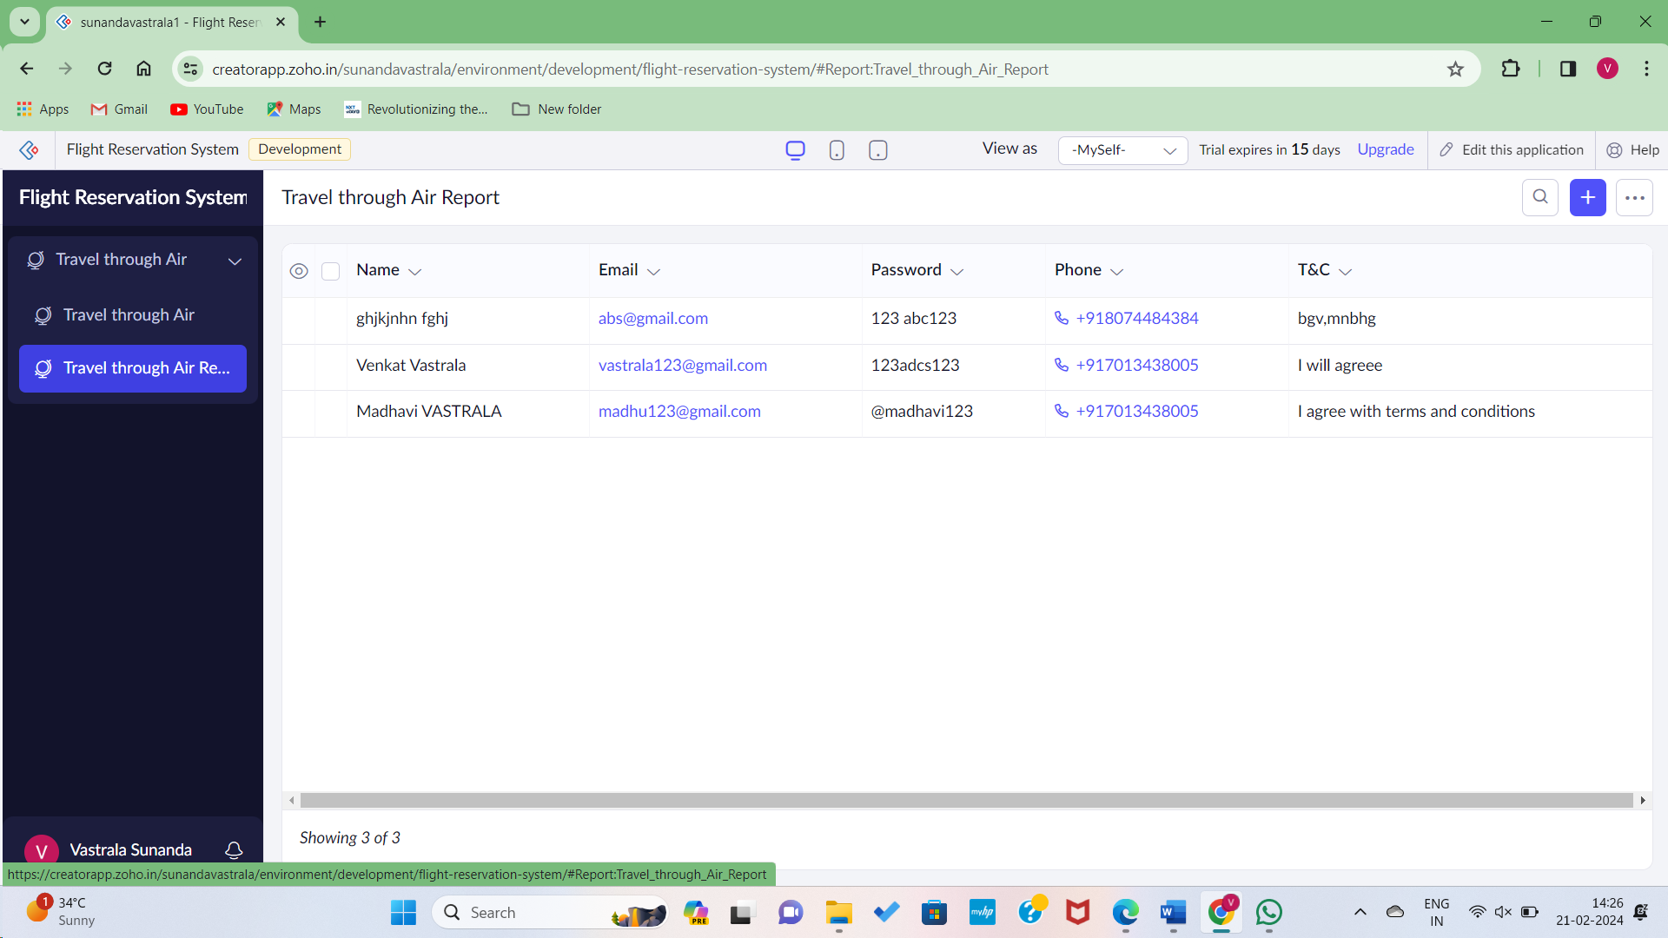

Login form completed.

Step 7: Go back to create Scratch to get new form.

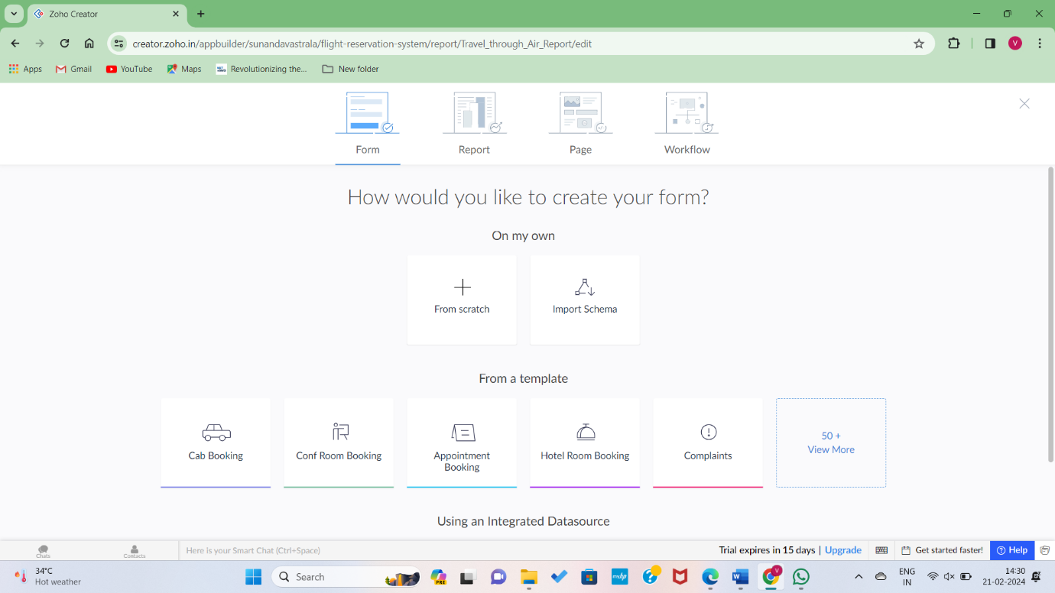Step 8: Go and enter the application form to create a new form.

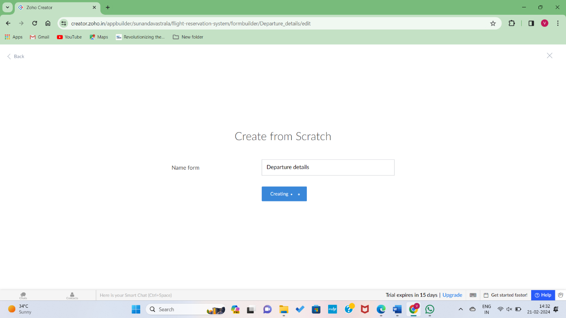

Step 9: Enetr the needed details about departure of the client.

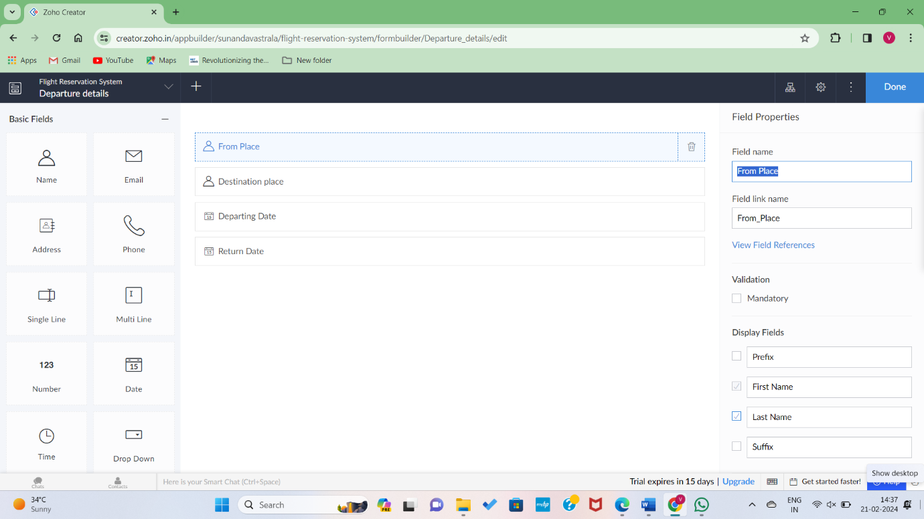

Step 10: Details Successfully submitted to data.

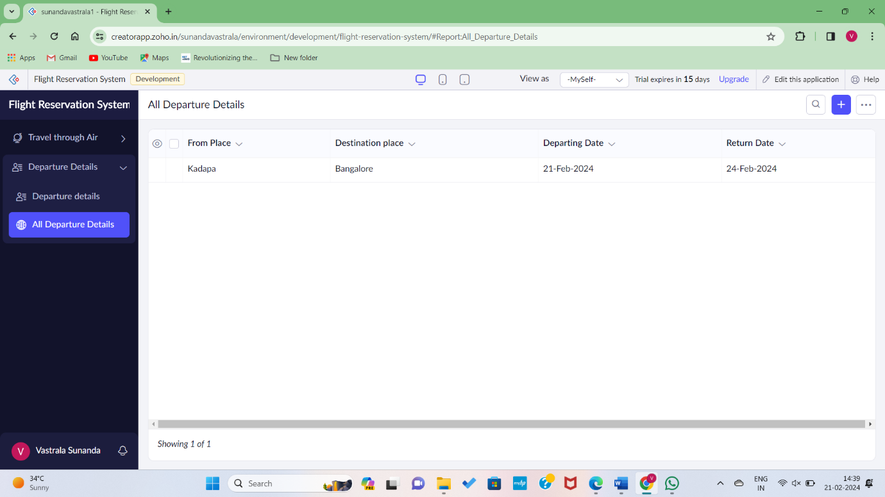

STEP11: Creating another form to enter details.

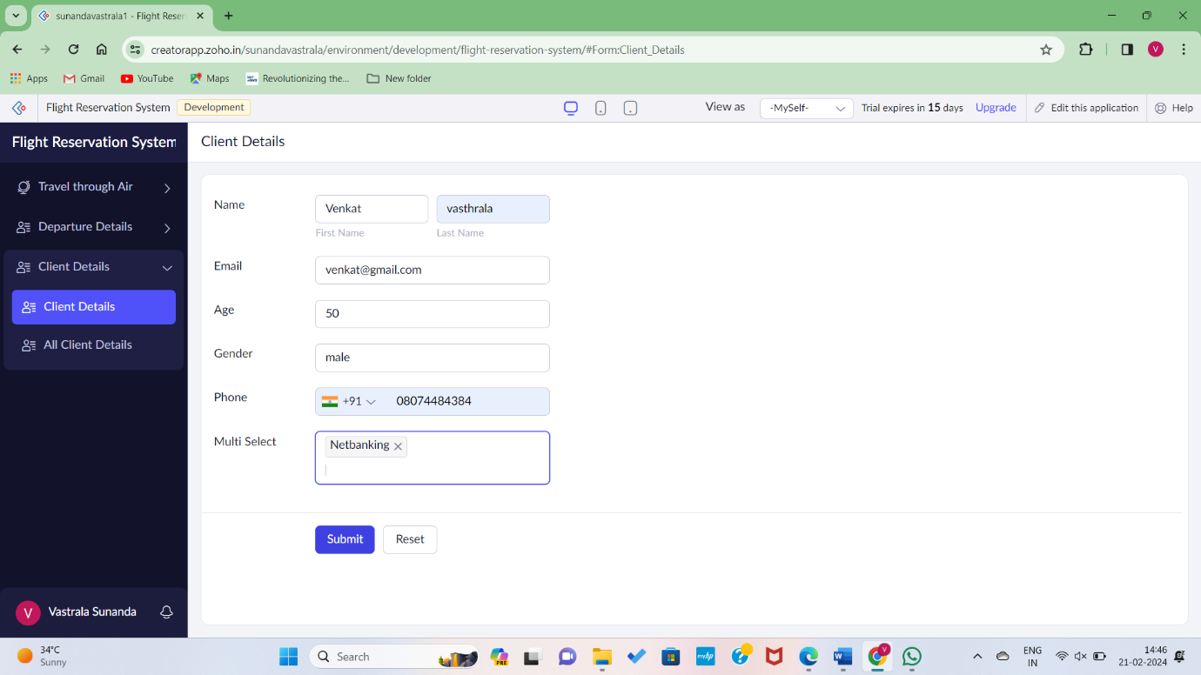

Step 12: Details are entered manually and payment transaction done. 